Pandas Wrangling –

Concatenation of Oct & Nov Sales Data

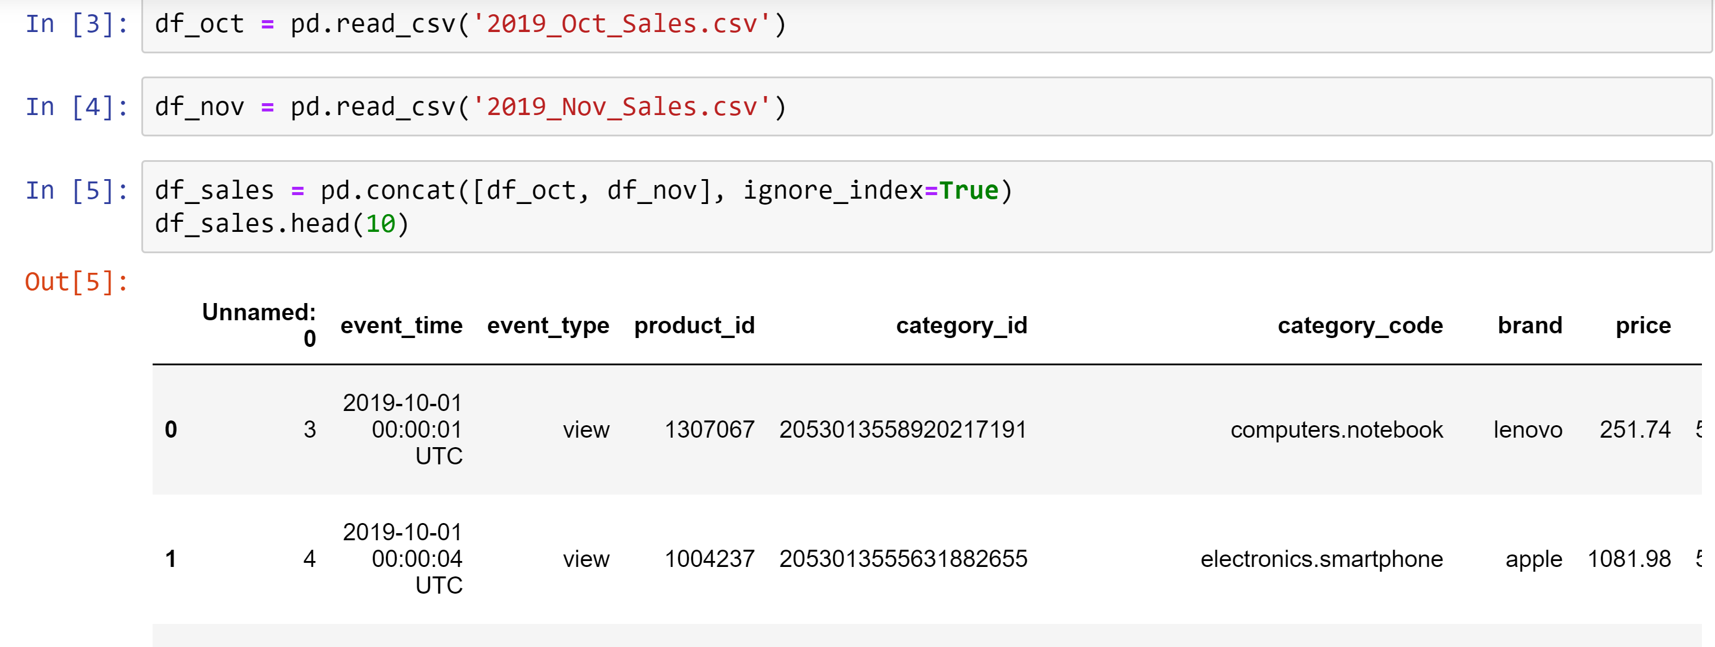

Null Value Analysis and imputing the values –

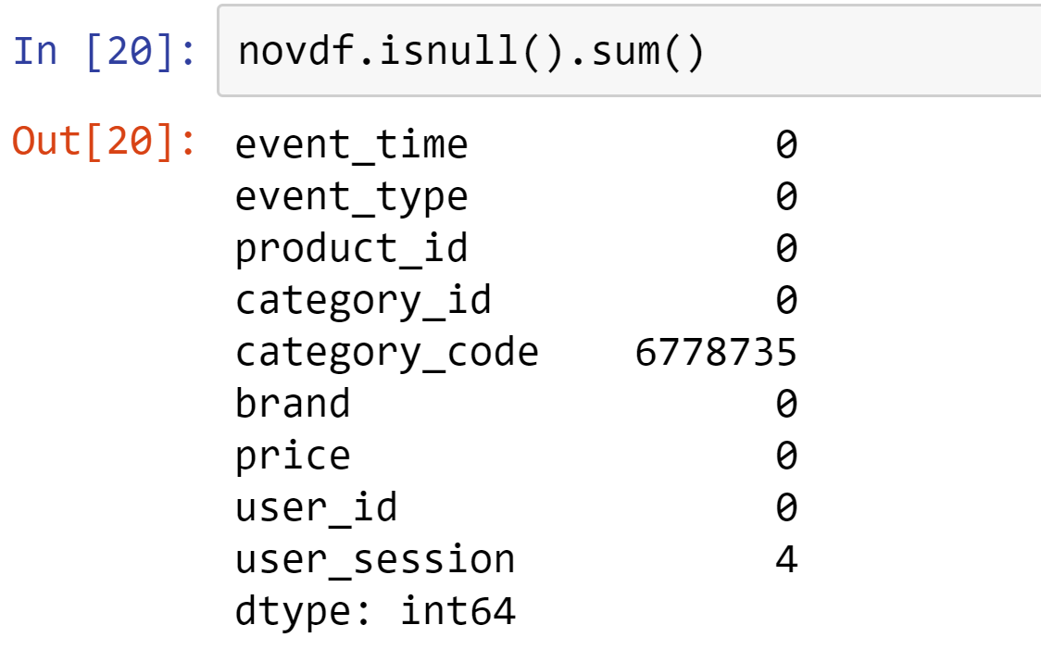

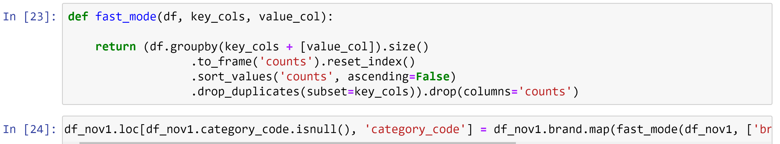

Converting ID columns to category –

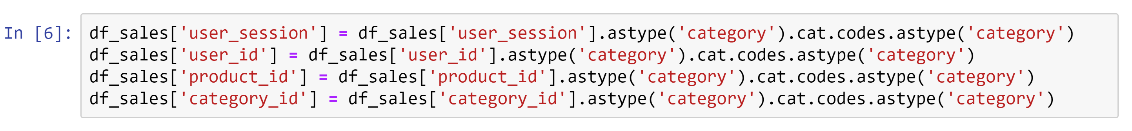

Slicing & Filtering the Dataset –

We tried various filtering ways using regex, filter using columns etc.

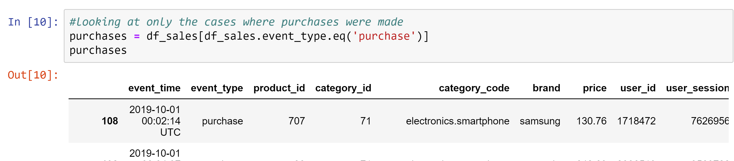

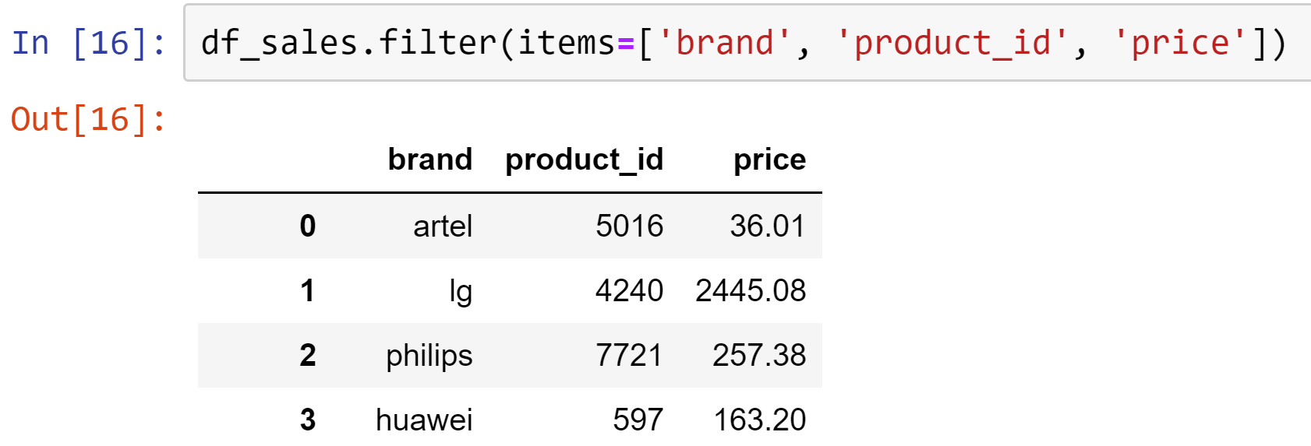

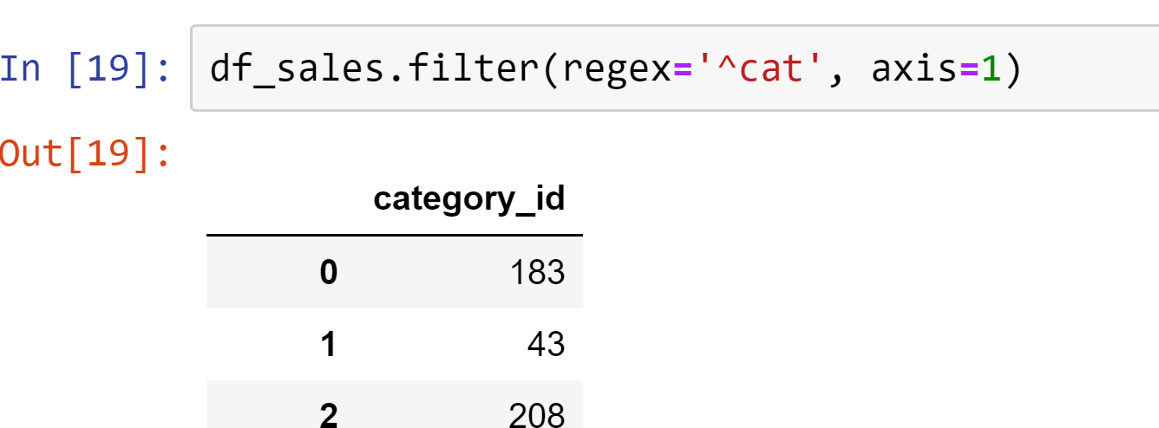

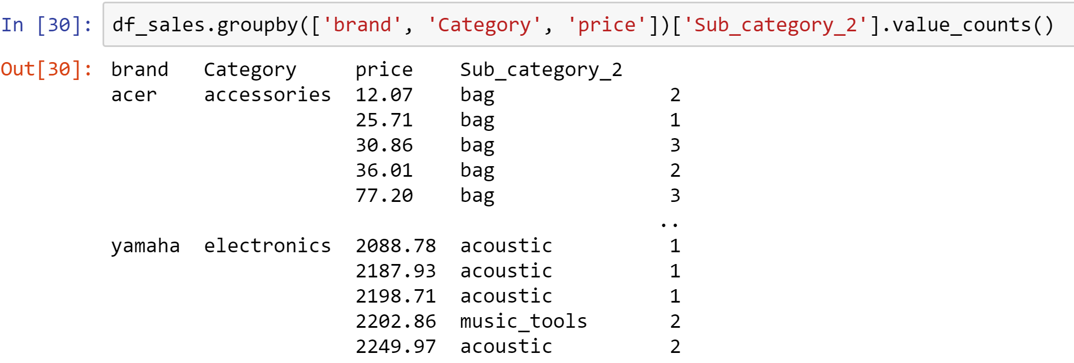

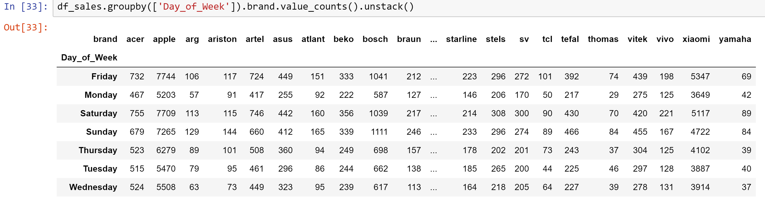

Creating Columns from existing ones –

We created the below columns –

1. Day of Week column from Date time
2. Created Category & Subcategory fields from Category Code
3. Created Event Hour & Time zone column from time stamp

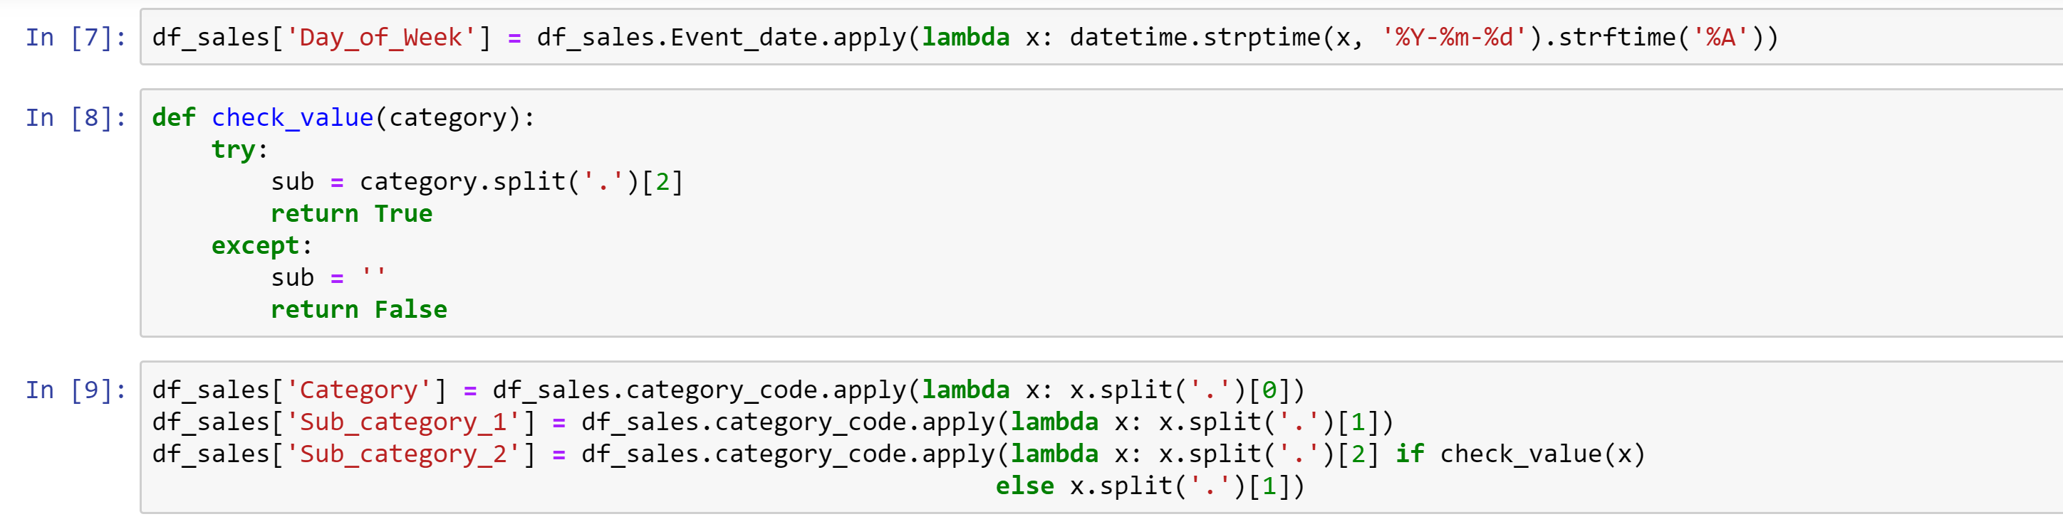

Visualisations –

